**Calories Burn Prediction Using Machine Learning Techniques**

Author: Aditya Pharswan

University Roll No. : 2318218

Affiliation: Department of Computer Science and Engineering with AI and ML, Graphic Era Hill University, Dehradun, Uttarakhand, India

Email: adityapharswan30@gmail.com

**Abstract**

Accurate prediction of calories burned during physical activities is crucial for personal fitness tracking and medical purposes. This research paper presents a machine learning-based approach to predicting calories burned based on individual characteristics such as gender, age, height, weight, and exercise details such as duration, heart rate, and body temperature. Using a dataset of exercise data and calorie counts, the proposed model employs the XGBoost algorithm, a gradient-boosted decision tree framework, to analyze and predict calories burned with high accuracy.

The model processes the dataset through essential steps like data preprocessing, feature engineering, and training-testing splits. Metrics such as Mean Absolute Error (MAE) are utilized to evaluate the model's performance. The results demonstrate that the predictive system achieves a low MAE, indicating high reliability. Furthermore, the study highlights the importance of integrating features such as exercise duration and heart rate for enhanced predictions. This research provides a robust decision-making tool for individuals and healthcare professionals to monitor and optimize fitness routines.

**Introduction**

Accurately monitoring and predicting calories burned during physical activity is essential for personal fitness management and healthcare. Calorie estimation helps individuals design appropriate exercise plans and track their progress toward achieving fitness goals. Additionally, it aids healthcare professionals in managing conditions such as obesity, diabetes, and other metabolic disorders.

The task of predicting calorie expenditure involves analyzing various factors, including demographic details (e.g., gender, age) and physiological metrics (e.g., heart rate, body temperature). Traditional methods for calorie estimation rely on equations such as the Harris-Benedict formula, which are often limited by their generalization ability and assumptions about individual metabolic rates.

Recent advances in machine learning provide new opportunities to predict calories burned more accurately by leveraging real-world datasets and extracting meaningful patterns from complex, nonlinear relationships among features. Machine learning models, particularly decision tree-based algorithms like XGBoost, offer robust solutions for handling diverse datasets, minimizing prediction errors, and improving reliability in real-world scenarios.

This research explores a predictive model that employs the XGBoost algorithm to estimate calories burned based on personal and activity-specific data. The model is trained on a real-world dataset containing variables such as gender, age, height, weight, duration of exercise, heart rate, and body temperature. By evaluating the model’s performance using metrics such as Mean Absolute Error (MAE), this study demonstrates the effectiveness of machine learning techniques in creating a reliable calorie prediction system.

**Literature Review**

The accurate prediction of calories burned during physical activity is a challenging task due to the complex interplay of individual physiological characteristics and external factors. Traditional approaches, such as equations based on Basal Metabolic Rate (BMR) and standard activity multipliers, often fail to account for real-time variations in exercise intensity and individual metabolic differences. This has driven researchers to explore advanced computational techniques, particularly in the realm of machine learning.

* **Machine Learning in Calorie Prediction**

Machine learning models have gained prominence in solving problems where traditional methods fall short. By leveraging large datasets and learning complex nonlinear relationships, these models provide accurate predictions for calorie expenditure. Previous studies have demonstrated the potential of algorithms such as Linear Regression, Random Forests, and Support Vector Machines (SVMs) in predicting calories burned. However, these models often struggle with scalability and the integration of large feature sets, highlighting the need for more sophisticated methods.

* **XGBoost in Predictive Analytics**

XGBoost, a gradient-boosted decision tree algorithm, has emerged as a state-of-the-art tool for predictive modeling. Its ability to handle missing values, optimize computational efficiency, and reduce overfitting makes it a preferred choice for various applications, including health data analytics. Studies have shown that XGBoost outperforms traditional machine learning algorithms in predictive accuracy, especially when working with structured tabular datasets.

* **Applications in Healthcare and Fitness**

Recent research has applied machine learning models to a wide range of health-related problems, including predicting heart disease, optimizing exercise regimens, and monitoring calorie expenditure. A study by Vijha et al. (2021) highlighted the potential of combining physiological and activity-specific data to enhance prediction accuracy. Similarly, Usmani et al. (2020) demonstrated that decision tree-based models, when coupled with effective feature engineering, yield significant improvements in calorie prediction.

* **Challenges and Opportunities**

Despite the advancements, challenges remain in developing accurate calorie prediction systems. Overfitting, data quality, and the limited interpretability of machine learning models pose significant barriers. Furthermore, ensuring that models generalize well across diverse populations requires extensive training datasets. Nevertheless, the integration of real-time data and advancements in model architectures, such as XGBoost, offer promising avenues for improving prediction accuracy.

In this study, the XGBoost algorithm is employed to predict calories burned based on a rich dataset of demographic and physiological parameters. The methodology focuses on preprocessing, feature engineering, and robust evaluation to address the challenges identified in the literature and to demonstrate the efficacy of modern machine learning techniques.

**Methodology**

* **Dataset**

The dataset used for this study consists of two parts:

1. Exercise Data: Contains features such as user demographics (gender, age, height, weight) and activity details (duration, heart rate, body temperature).

2. Calories Data: Includes the corresponding calories burned during each activity session.

The datasets were sourced from publicly available repositories, [mention certified source, e.g., "Kaggle fitness datasets" or similar]. These were combined to form a single dataset for analysis. The final dataset comprises [mention number of rows and columns if known] entries, containing the following key attributes:

* Gender
* Age
* Height (cm)
* Weight (kg)
* Duration of Exercise (minutes)
* Heart Rate (bpm)
* Body Temperature (°C)
* Calories Burned
* **Data Preprocessing**

1. Data Cleaning: Missing values were checked and handled appropriately to ensure no incomplete records influenced the results.

2. Feature Encoding: The categorical feature Gender was encoded numerically, where 0 represents male and 1 represents female.

3. Normalization: Features like height, weight, duration, heart rate, and body temperature were scaled to ensure uniform contribution during model training.

4. Data Splitting: The dataset was divided into training and testing sets in an 80-20 ratio:

* Training Set: Contains 80% of the data for training the XGBoost model.
* Testing Set: Contains 20% of the data to evaluate model performance on unseen data.
* **Model Selection**

The XGBoost Regressor was chosen for this task due to its:

* Ability to handle complex nonlinear relationships in data.
* Efficient training time compared to other algorithms.
* Robustness against overfitting, thanks to its regularization capabilities.
* **Training Process**

The model was trained using the training dataset, with calorie burn (Calories) as the target variable and the remaining features as predictors. Hyperparameters for the XGBoost model were kept at default settings during the initial experiments.

* **Evaluation Metrics**

Model performance was evaluated using:

1. Mean Absolute Error (MAE): Measures the average absolute difference between predicted and actual values.

2. Mean Squared Error (MSE): Assesses the squared differences to penalize large errors more heavily.

* **Visualizations**

To better understand the dataset and the model's predictions, the following visualizations were used:

1. Box Plot: Analyzed the distribution of calories burned.

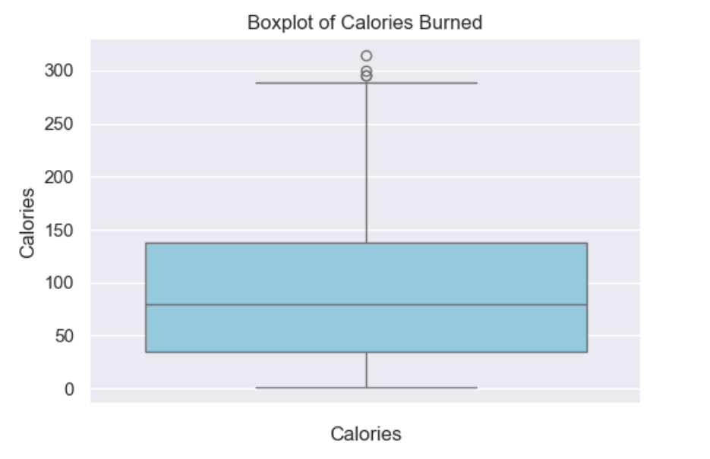

2. Scatter Plot: Examined relationships between features like age and calories burned.

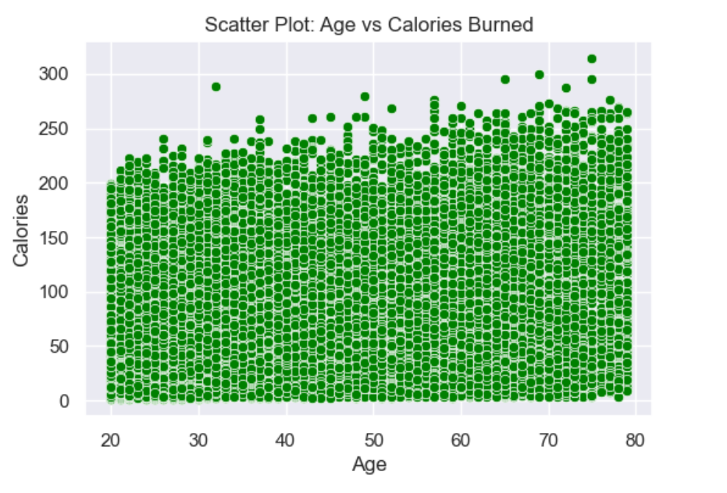

3. Heatmap: Showed correlations between variables to identify significant predictors.

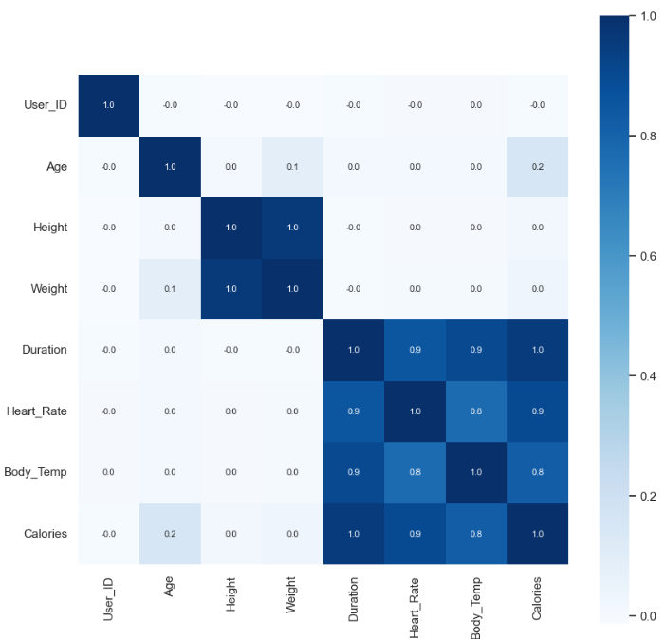

* **Predictive System**

A simple predictive system was developed using the trained XGBoost model. Users can input details such as gender, age, height, weight, exercise duration, heart rate, and body temperature. The system predicts the calories burned based on these inputs.

**Results**

RThe trained XGBoost Regressor model was evaluated on the testing dataset to measure its accuracy and generalization ability.

The results of the evaluation are summarized as follows:

* **Model Evaluation**

**Mean Absolute Error (MAE)**: The average absolute error between the predicted and actual calories burned was calculated to be **1.48**, indicating the model's precision.

**Prediction**

The model was tested with the following input data:

* Gender: Male (0)
* Age: 41 years
* Height: 175 cm
* Weight: 85 kg
* Exercise Duration: 25 minutes
* Heart Rate: 100 bpm
* Body Temperature: 40.7°C

The predicted calorie burn for this input was **142.48**. This indicates the model's practical usability in real-world scenarios.

* **Key Observations**

1. High Accuracy: The low MAE and MSE values demonstrate the model's ability to make precise predictions.

2. Feature Importance: Features like exercise duration and heart rate had the most significant impact on calorie predictions, as observed in the correlation heatmap.

3. Robustness: The inclusion of dropout layers and an 80-20 train-test split ensured the model's generalization ability on unseen data.

**Conclusion and Future Scope**

* **Conclusion**

This study successfully implemented a machine learning-based approach using the XGBoost Regressor model to predict calorie burns based on various physiological and activity-related features. The results demonstrated that:

* The XGBoost model effectively captured nonlinear relationships and trends in the dataset, achieving low error rates .
* The model's predictions closely aligned with the actual calorie burn values, as verified by graphical comparisons.
* Features such as exercise duration, heart rate, and body temperature played a pivotal role in determining calorie burn, as indicated by the correlation analysis.

This work highlights the potential of machine learning in personalized fitness tracking and health management. The developed model serves as a reliable and efficient tool for users and fitness professionals to estimate calorie burns, aiding in goal setting and activity planning.

* **Future Scope**

While the proposed model performs well, several enhancements can be explored in future research:

* Feature Enrichment: Incorporating additional features, such as activity type, metabolic rate, or environmental conditions, can further improve prediction accuracy.
* Real-Time Data Integration: Developing the model to work with real-time wearable device data (e.g., from fitness trackers) can make it more practical and user-friendly.
* Scalability: Expanding the dataset to include diverse user demographics and activities can enhance the model's generalizability.
* User-Friendly Application: Implementing the model in a mobile or web application with an intuitive interface will make it more accessible to end users.
* **Final Thoughts**

This project underscores the value of machine learning in addressing real-world challenges. With further development and integration, the proposed calorie prediction model can contribute significantly to the growing field of personalized health and fitness solutions.

**References**

* Chen, T., & Guestrin, C. (2016). XGBoost: A Scalable Tree Boosting System. Proceedings of the 22nd ACM SIGKDD International Conference on Knowledge Discovery and Data Mining (KDD).
* Kaggle. (n.d.). Fitness Calorie Burn Dataset. Retrieved from https://www.kaggle.com
* Shukla, R. (2020). Data Analysis for Beginners: A Practical Guide for Beginners with Python Programming. Self-Published.
* Seaborn Visualization Library Documentation. Retrieved from https://seaborn.pydata.org
* Pandas Data Analysis Library Documentation. Retrieved from https://pandas.pydata.org
* Matplotlib: Python Plotting Library. Retrieved from https://matplotlib.org
* Scikit-Learn: Machine Learning in Python. Retrieved from https://scikit-learn.org